AFTER THE BLITZ…

I have totally changed my mind. The war is an awful thing and I almost died. I never want another war again oh and all this rationing is absurd, I have never eaten so little.

Every day another house, person or building crumbles. I don’t know what to do with myself. A row of houses was there and then it was just me. I had to do everything on my own.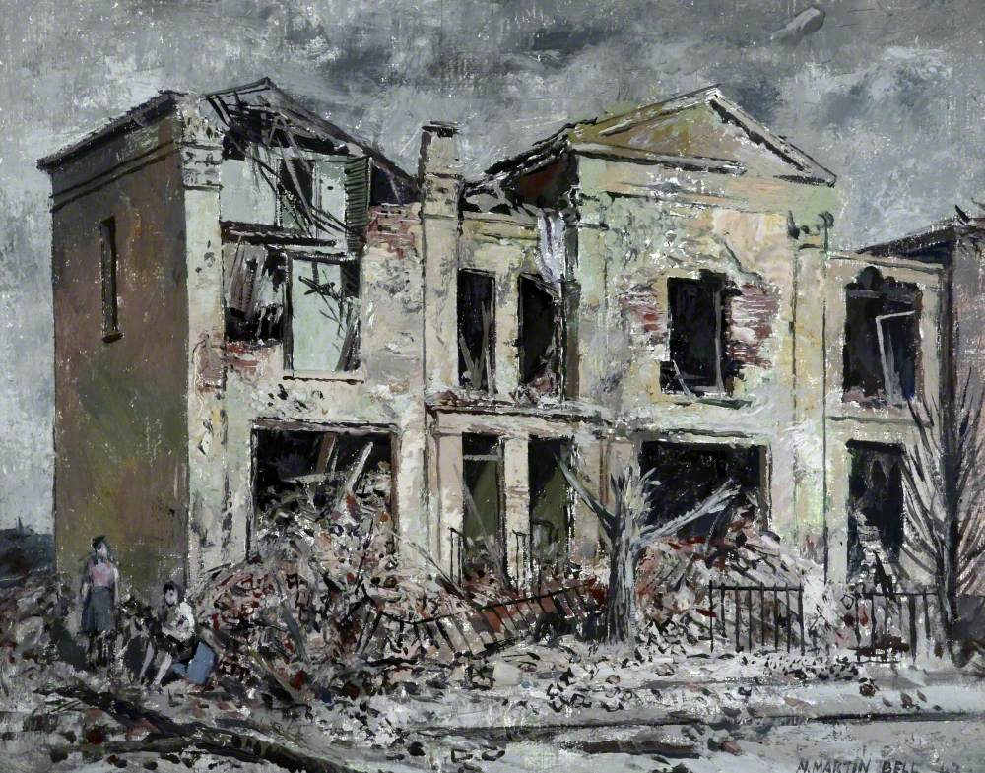

AFTER BLITZ. 